**SPH 4U**

**SAMPLE FINAL LABORATORY EXAMINATION**

**Name: _____________________________________________**

**Instructions:**

1. All work is to be completed on the examination sheets provided.
2. You are allowed to collaborate with a partner **ONLY** on gathering data for each experiment. ALL calculations are to be performed individually.
3. You are allowed your ‘cheat sheet’ for the examination.
4. Be sure to show ALL work with sentences, diagrams (FBDs, Energy Bar diagrams etc.) describing your solution to each problem.
5. If you have read these instructions then place a smiley face after the last letter of your last name for one bonus mark.

**NOTE TO READER:**

* I have included various samples for you to consider.
* Consider choosing ONE of these as a practice question prior to the exam so they get the idea
* Use 6 STATIONS generally for a 2 – 2.5 hour exam
* The lab exam works on an assumption that your learning environment had plenty of opportunity for experimental ‘play’. In this way, the exam becomes a natural extension of what they have been doing during your course.
* Finally, this is an idea and is ALWAYS open to improvement

Reach me here! - [glennwagnerphd@gmail.com](mailto:glennwagnerphd@gmail.com)

**STATION 1: Equilibrium Force Model**

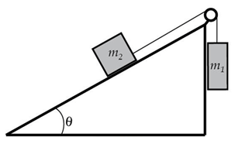

**Given:**

* Protractor and/or leveler app
* Mass scale

**Required to find:**

1. **Together:** Determine the value of the masses and measure the angle of the incline.
2. **Individually:** The value of the co-efficient of friction, µ, needed to keep the system at rest.

**STATION 2: Constant Velocity/Acceleration Models and Energy Model**

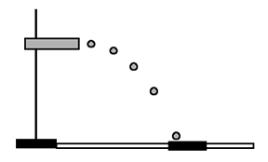**Given:**

* Metre stick
* Ruler
* Mass scale

**Required to find:**

Fire the ball using the apparatus given. Then…

1. **Together:** Measure the horizontal distance, height of the ball, and compression of the spring
2. **Individually:** The initial speed of the ball
3. **Individually:** The spring constant of the spring

**STATION 3: Constant Force and Constant Acceleration Models**

(**note to reader:** result between theory and experiment can vary in this experiment, sometimes widely. It is the process here that counts and not really the %error)

**Given:**

* Protractor or leveler app, Stop watch, Mass scale

**Required to find:** Place the mass on the incline and release from rest. Then use the equipment provided to find the acceleration in two ways:

1. **Together**: Measure the time and distance for the mass to reach the bottom
2. **Individually**: Determine the **experimental value** of the acceleration using the available equipment.
3. **Individually**: Sum the forces and calculate the **theoretical value** for the acceleration. Note that µk = 0.22.
4. **Individually**: Determine the % error between the two values.

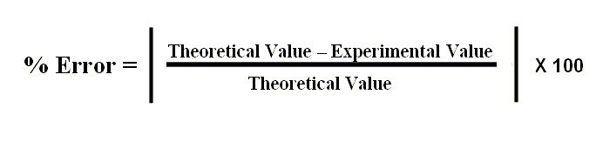

**Given:**

* Metre stick
* Stop watch
* Mass scale

**THEORETICAL CALCULATION**

**EXPERIMENTAL CALCULATION**

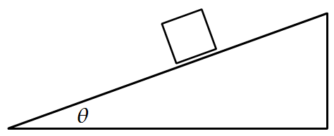

**% Error =**

**STATION 4: Central Force Model/Constant Velocity Model**

**Note to reader**: These are called Hot Wheels Rev-Ups. Sadly, I don’t think they are made anymore. But look around!)

**Given:**

* Ruler
* Mass scale
* Stopwatch

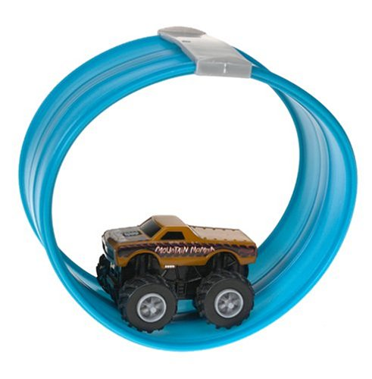

**Required to find:**

1. **Together:** Find the time for two (2) rotations around the track as the car moves at a constant speed
2. **Individually:** Find the constant speed of the car.
3. **Individually:** The magnetic force between the car and track has been measured to be 0.9 N. Find the force by the track on the car at the *top* of the loop-the-loop.

**STATION 5: Equilibrium and Energy Models**

**Given:**

* Hooke’s Law apparatus
* Masses

**Required to find:**

1. **Individually**: The spring constant *k* of the spring, in N/m.
2. **Individually**: The energy stored in the spring when stretched 6 cm.

Use the graph paper below and the white space to the right of it to show your work.

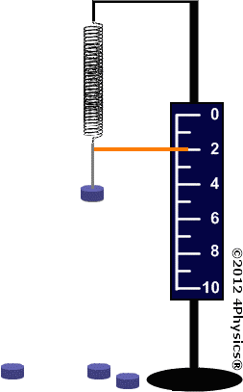

**Work space below**



|  |  |  |
| --- | --- | --- |
| **mass (kg)** | **Extension, x, (m)** | **Fx (N)** |
| 0 | 0 | 0 |
|  |  |  |
|  |  |  |
|  |  |  |
|  |  |  |

**STATION 6: Equilibrium Force Model**

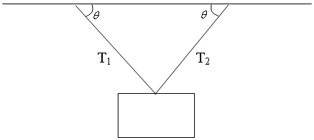

**Given:**

* Protactor
* Leveler
* Data from two spring scales attached to an

unknown hanging mass.

**Required to find:**

**Together:** Measure the angles of the two ropes.

**Individually:** Calculate the value of the unknown mass

**STATION 7: The Loop-the-Loop**

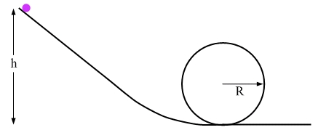**Given:**

* Metre stick and/or ruler
* Mass scale

**Required to find:**

Place ball on the track. Then release the ball from rest at a height of _____ m. Then find…

1. The speed at the top of the loop-the-loop.
2. The force by the track on the ball at the top of the loop-the-loop.

**STATION 8: Energy Model**

**Given:**

* Metre stick/ruler
* Mass scale

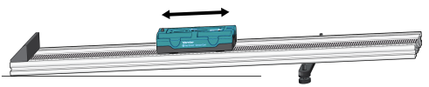

**What to Do**

1. A cart is on a track elevated to an incline
2. Compress the spring-loaded plunger fully so that it is at rest against the block.
3. Activate the plunger and let the cart move until it comes to rest up the incline.

**Required to Find**

**Together:** Measure the the change in height relative to the table and the mass of the cart

**Individually**: Calculate the spring constant that is inside the cart

**STATION 9: Accelerating Cart**

**Note to reader**: Alternatively, flip the cart upside down to develop friction. Find acceleration then calculate mu_k.

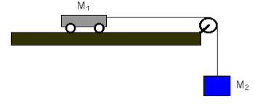

**Given:**

* Metre stick
* Stop watch
* Mass scale

**Required to find:**

Allow M2 to fall from rest thereby accelerating the system.

Assume NO FRICTION during the motion.

1. Find the acceleration of the system.
2. Find tension in the string.

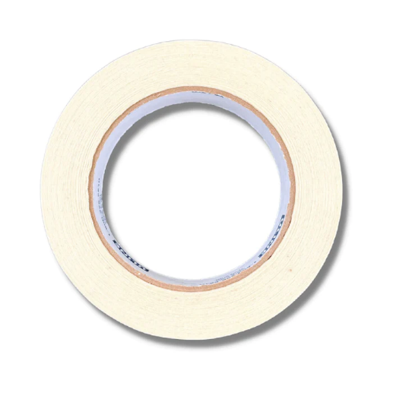**Station 10: Central Force Model**

**Given:**

* Stopwatch
* Ruler
* Masking tape roll
* Small ball
* Mass scale

**Required to find:**

Place the ball inside the masking tape roll. Moving the roll such that the ball moves at a constant speed around the inside wall of the tape.

**Together:** Find the time for 10 rotations around the circle

**Individually:**

1. Calculate the speed of the ball
2. Determine the force by the masking tape wall against the ball

**STATION 11: Equilibrium Force Model**

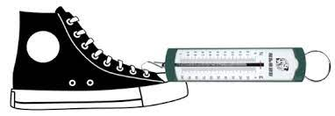**Given:**

* Spring scale
* Mass scale

**Required to find:**

The co-efficient of static and kinetic friction between the shoe and the surface on which it sits.

**Together**

Find the maximum force needed for the shoe to begin moving. Then, find the force needed to move the shoe at a constant velocity.

**Individually**

Calculate the co-efficient of static and kinetic friction between the shoe and the surface on which it sits.